* Use Cases regarding Attendance and Login

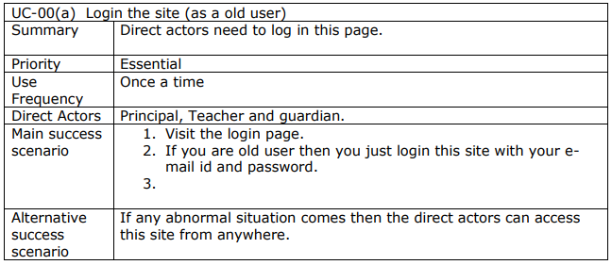

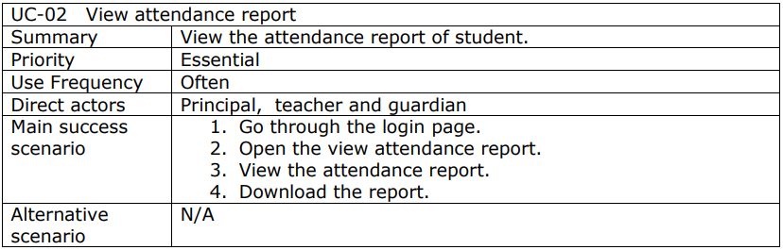

* Use Cases regarding Class Test